Using INetSim on Kali Linux

**Starting your Win2008-Target Virtual Machine**

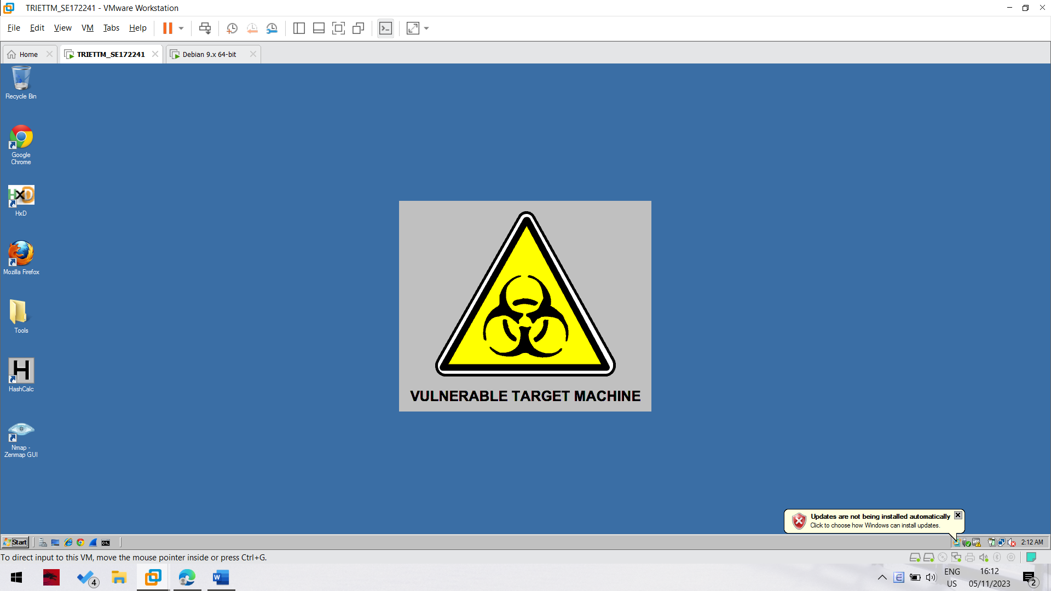

**Starting the Kali Linux Machine and Adjusting Networking**

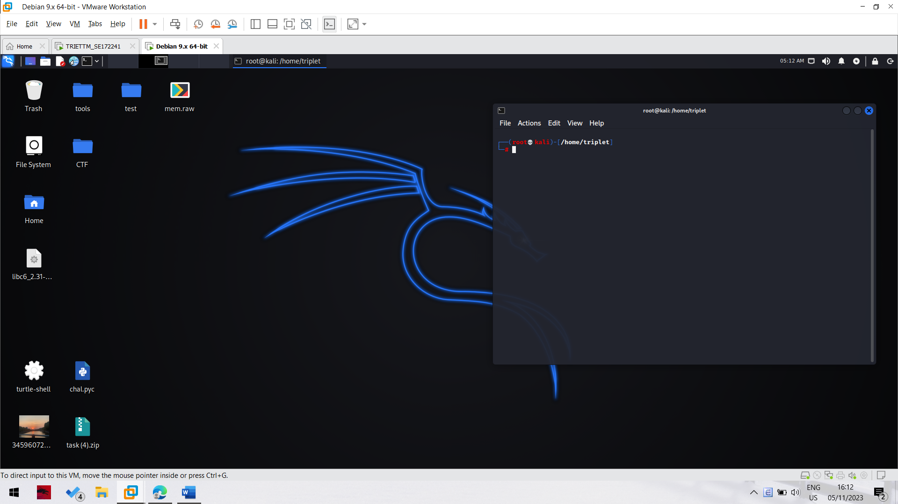

**Setting the Kali Linux VM to NAT Networking**

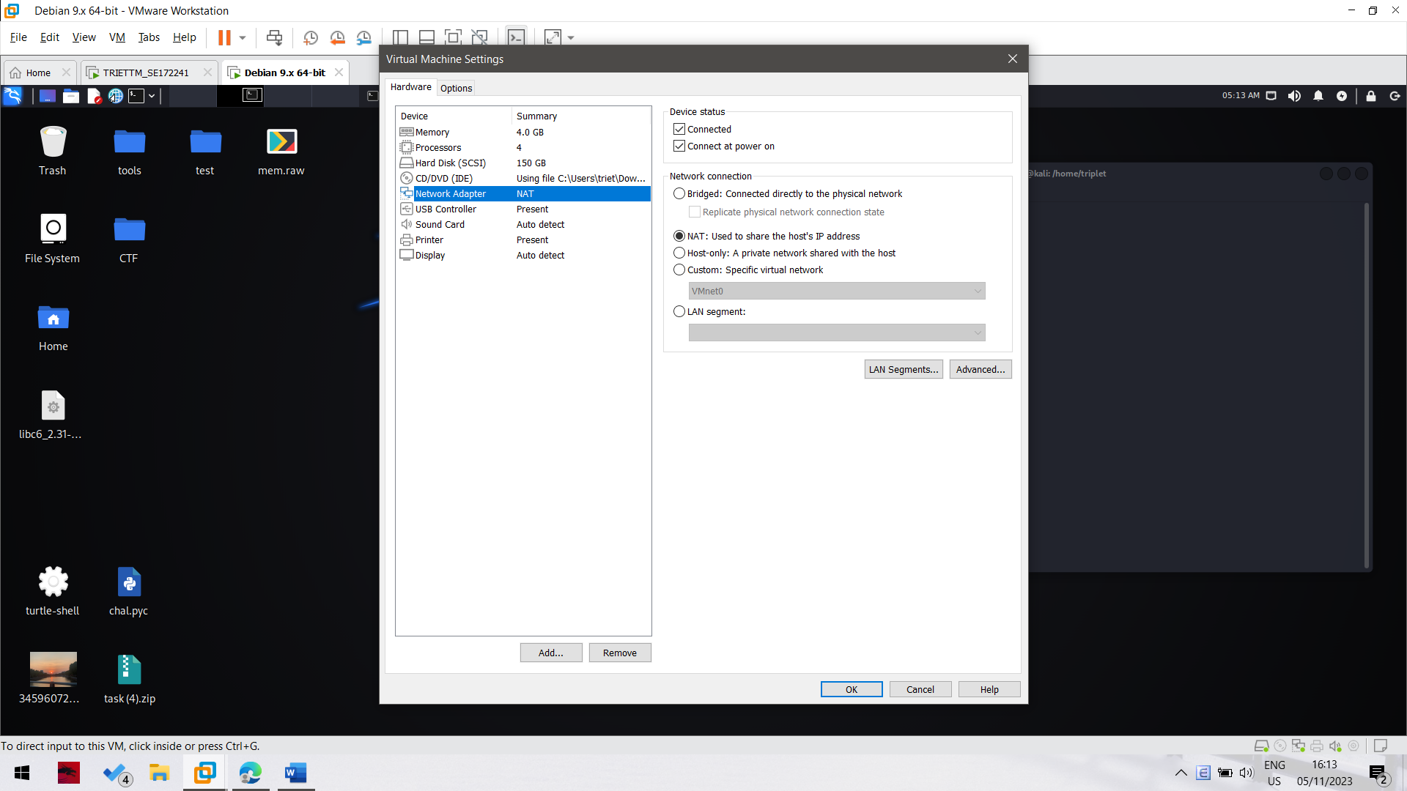

**Finding the Kali Machine's IP Address**

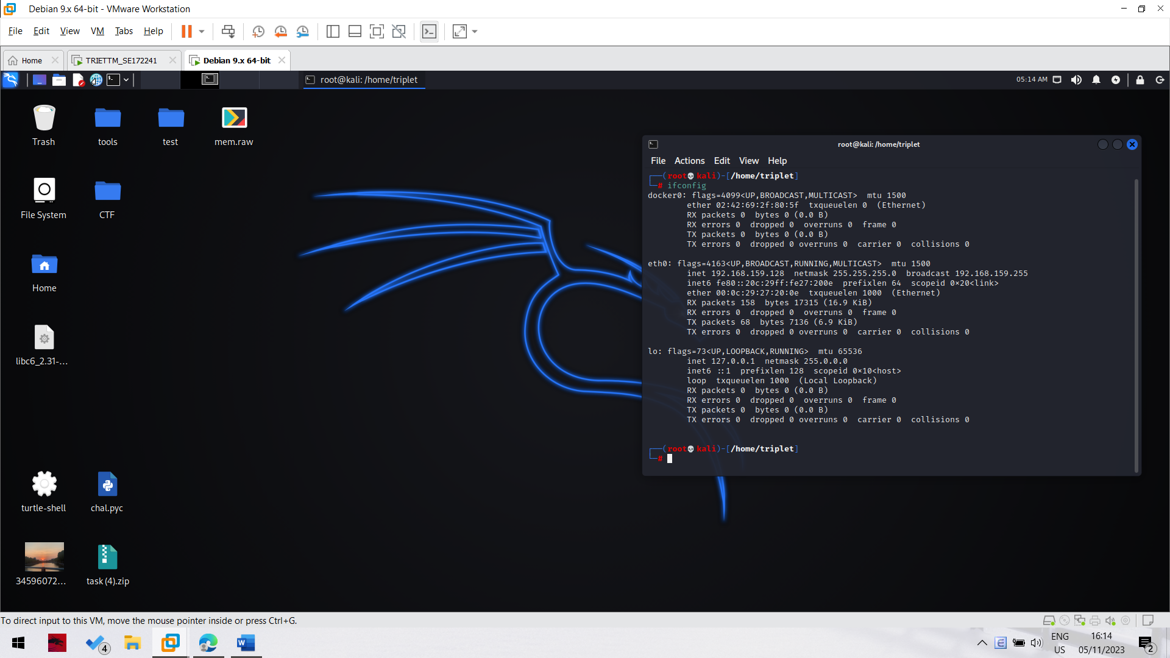

**Checking for a Web server**

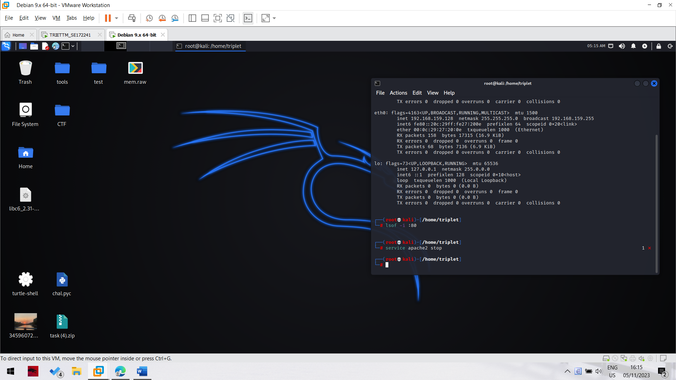

As we can see that this current kali machine does not start apache service yet. So that we do not need to stop this service.

**Configuring inetsim**

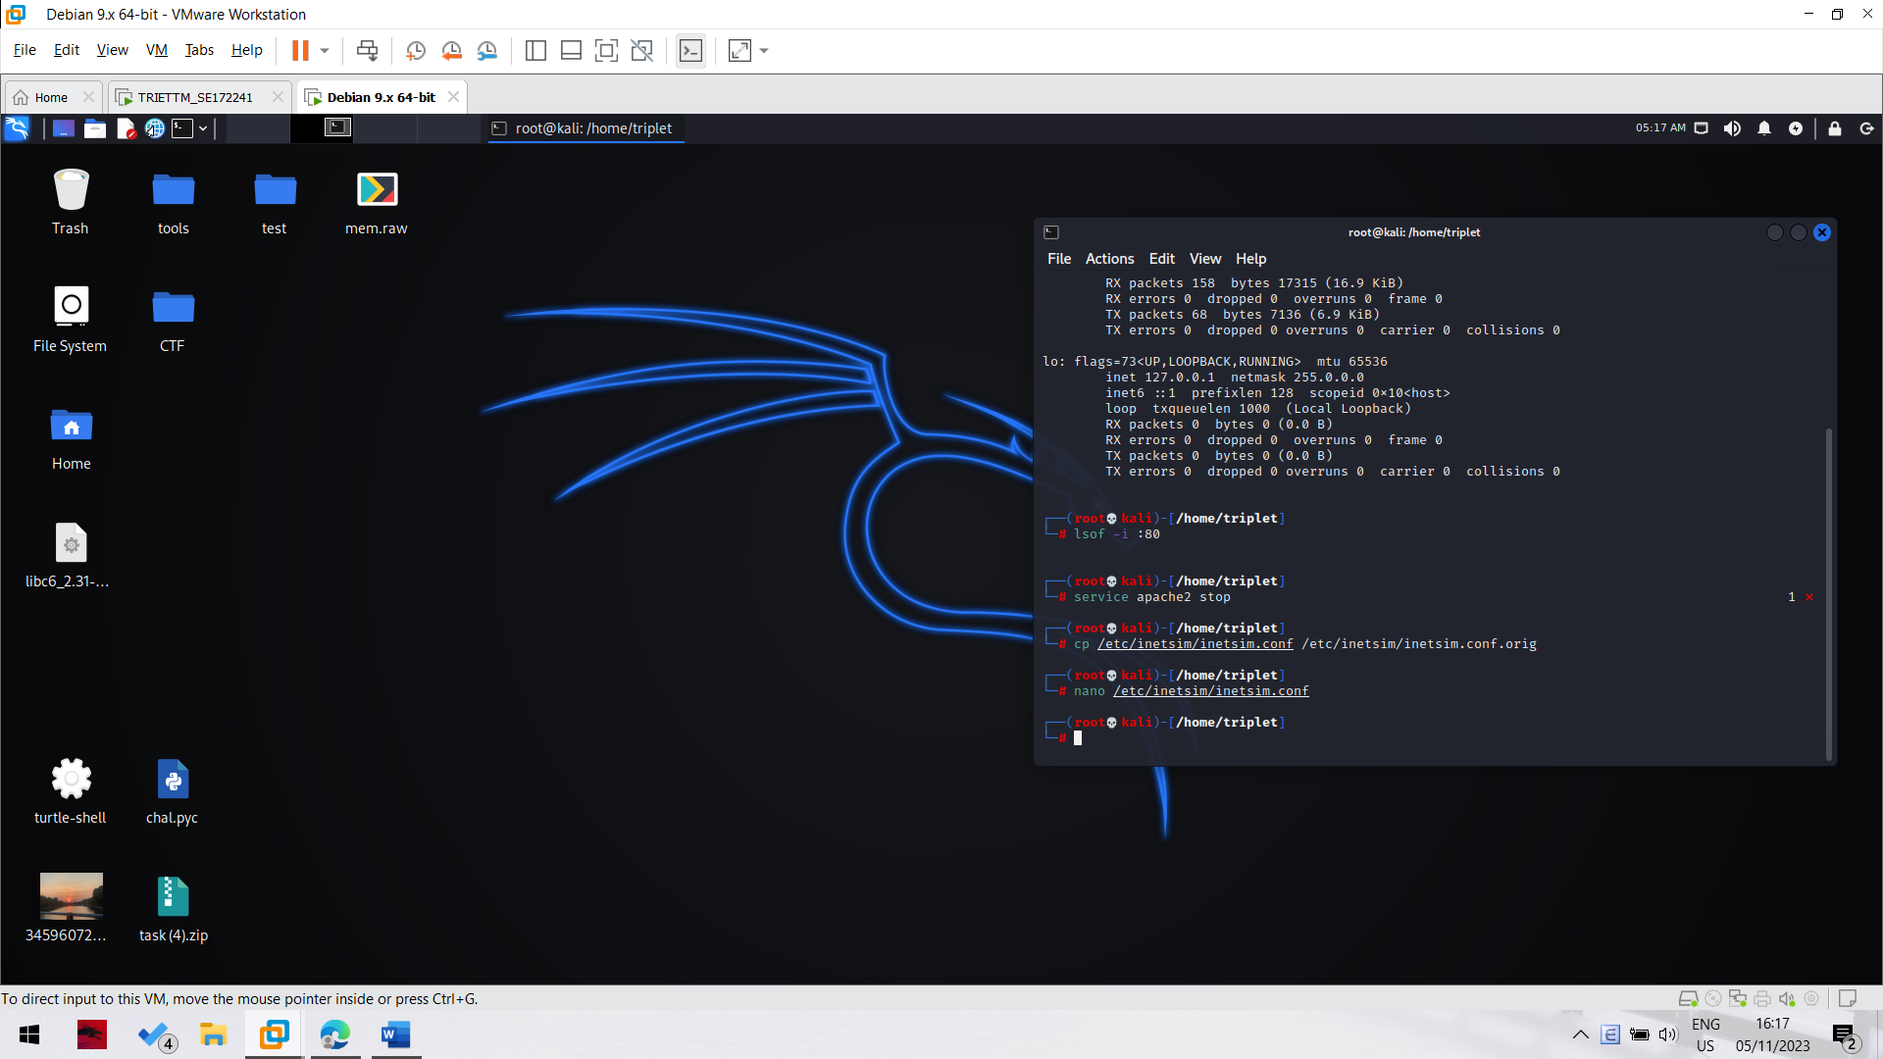

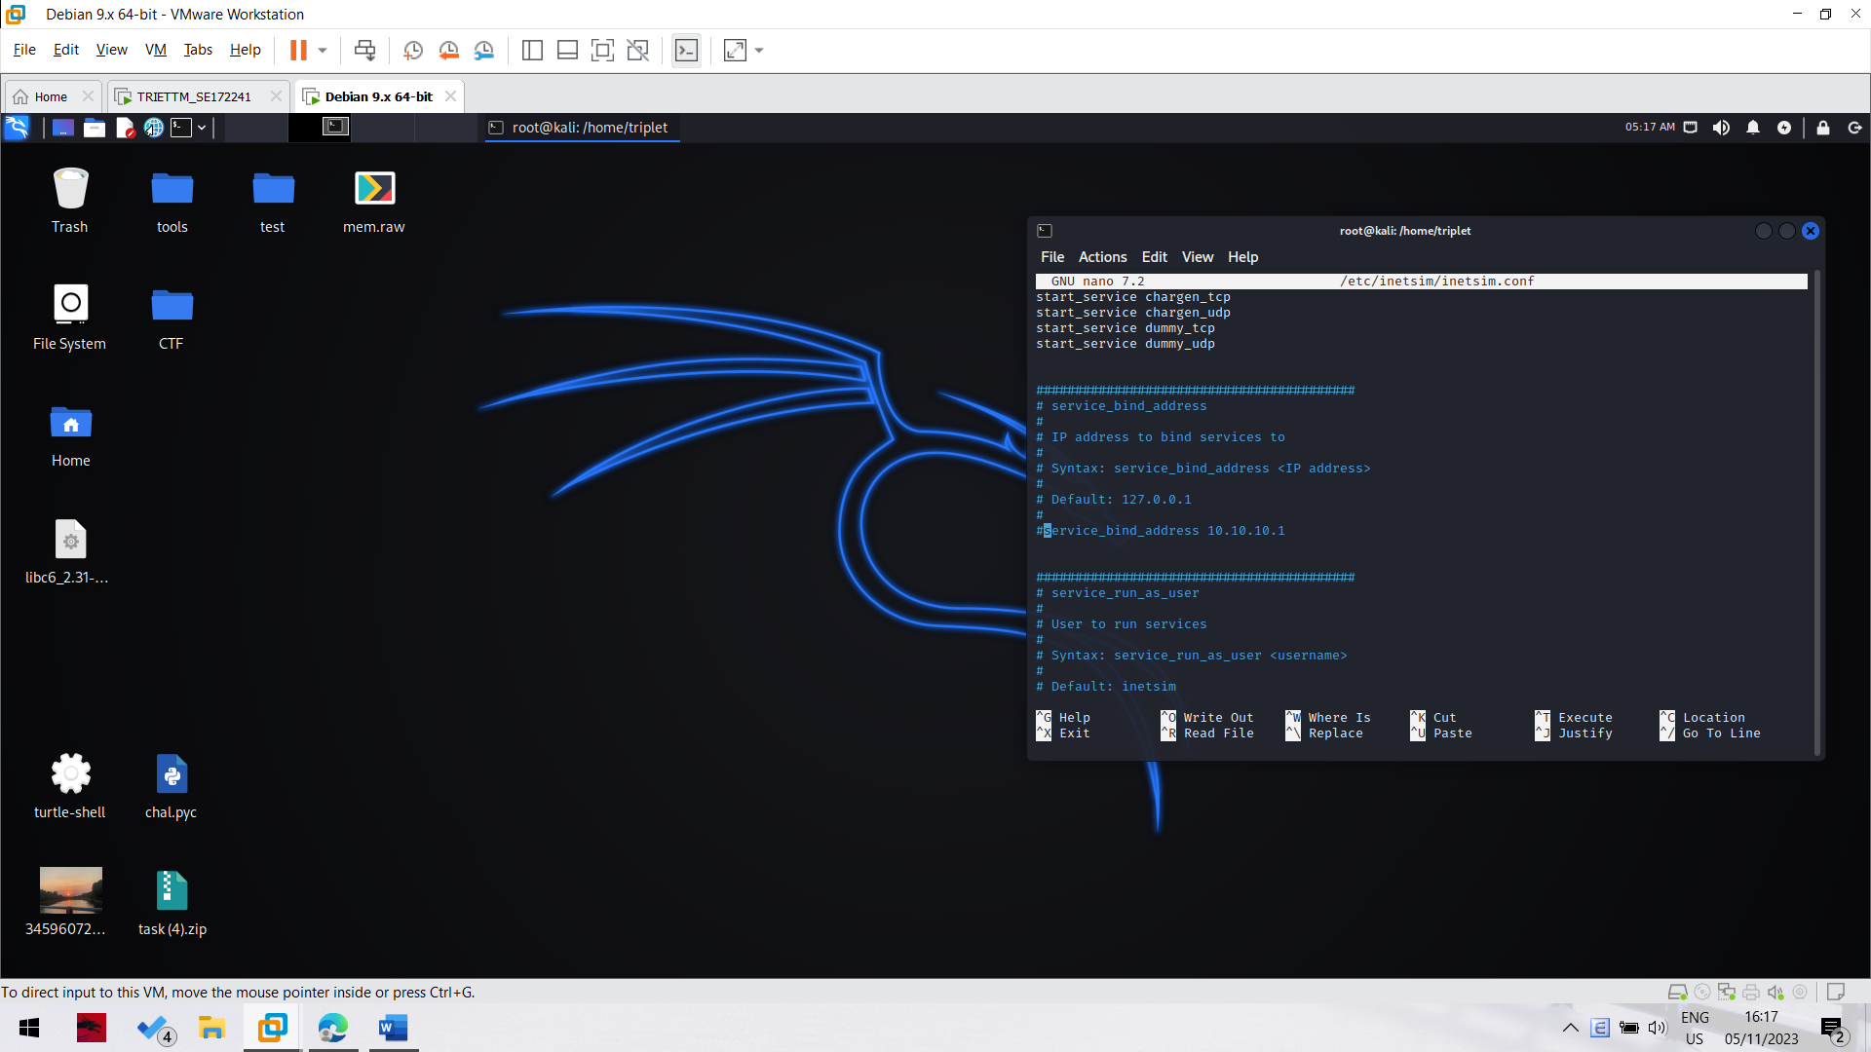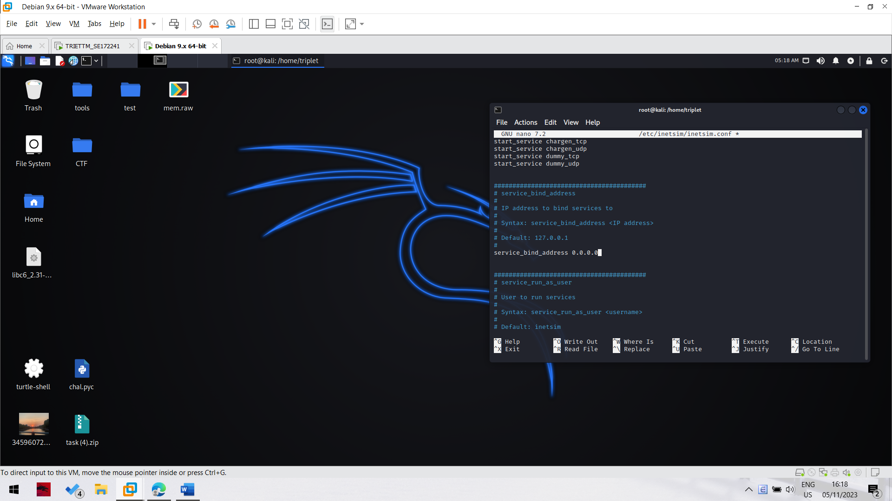

Change the default service_bind_address to 0.0.0.0

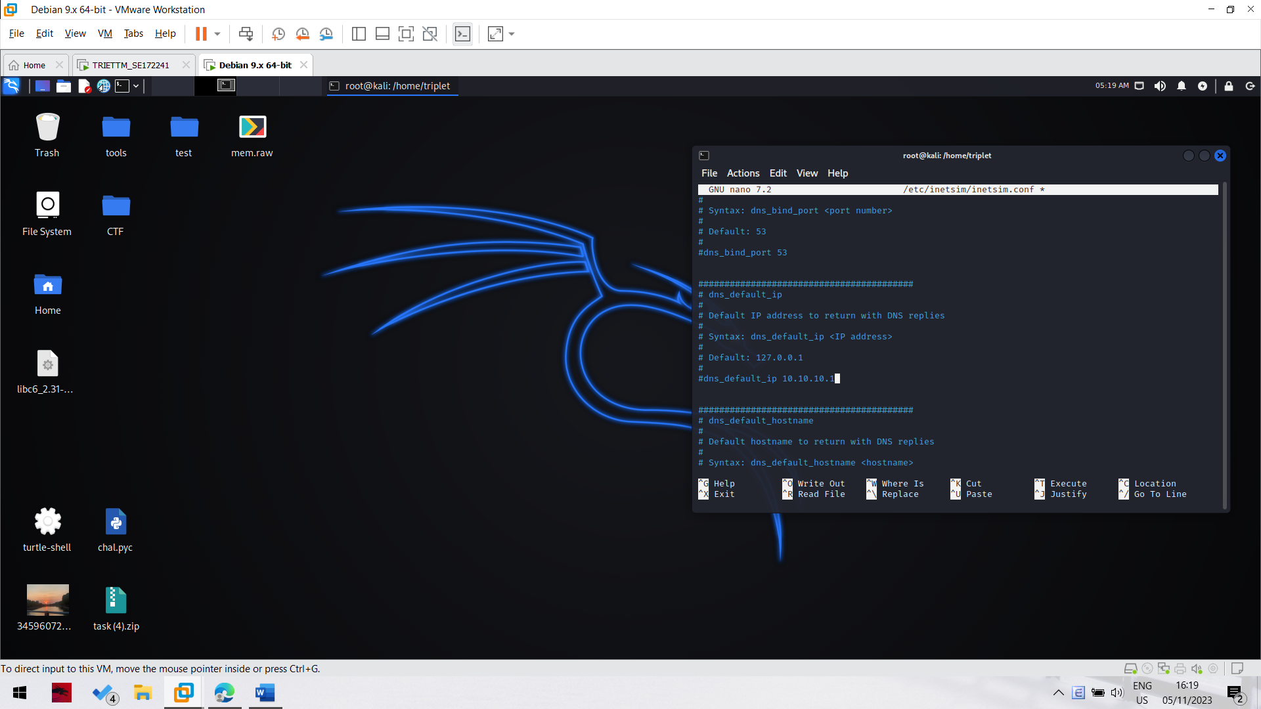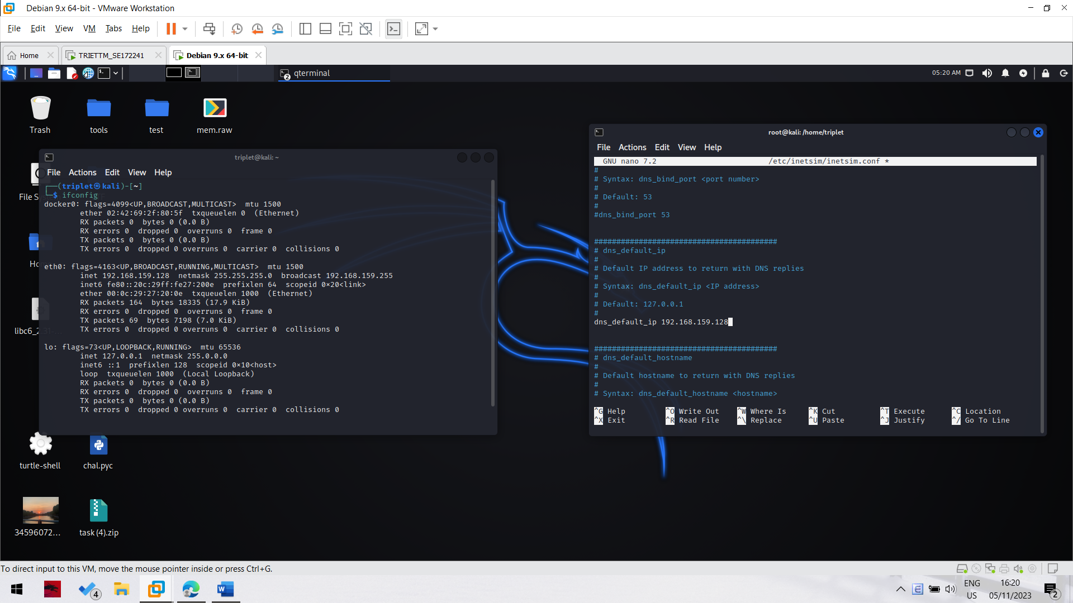

Replace the default dns ip address to the ip address of the machine kali.

Then save the configuration file and running inetsim. 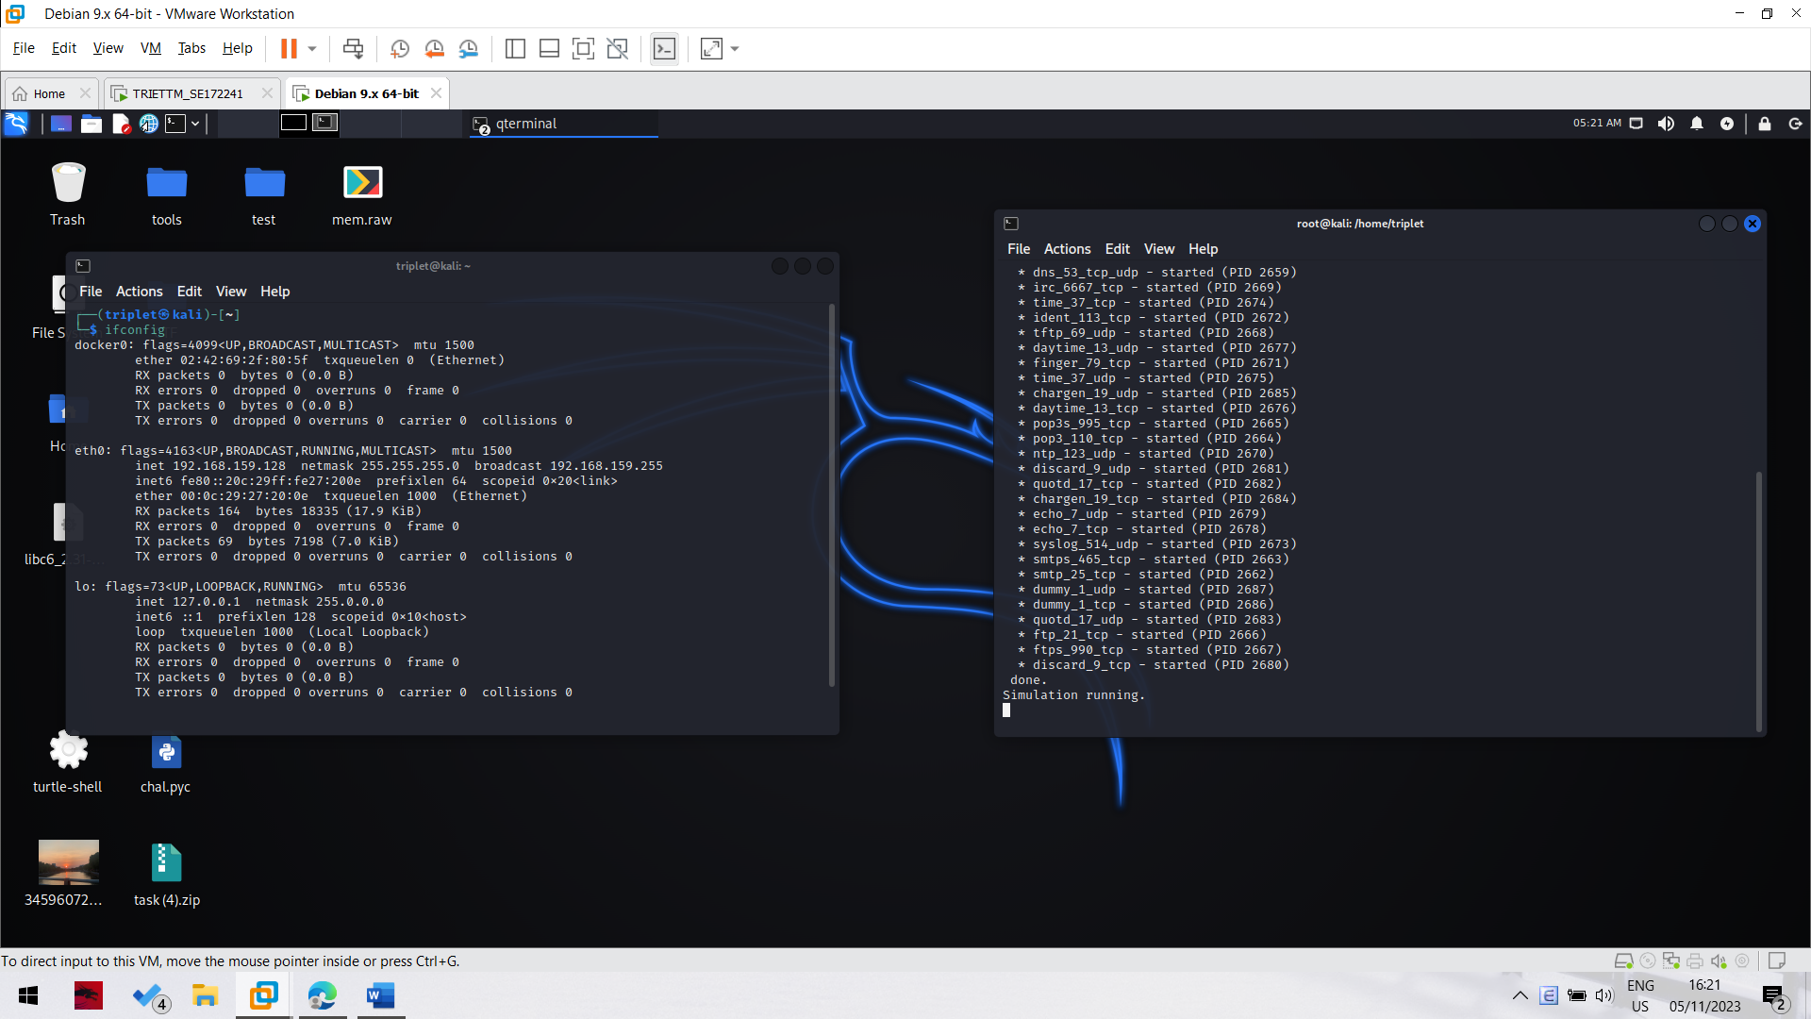

The inetsim is running successfully.

**Start Your Windows VM**

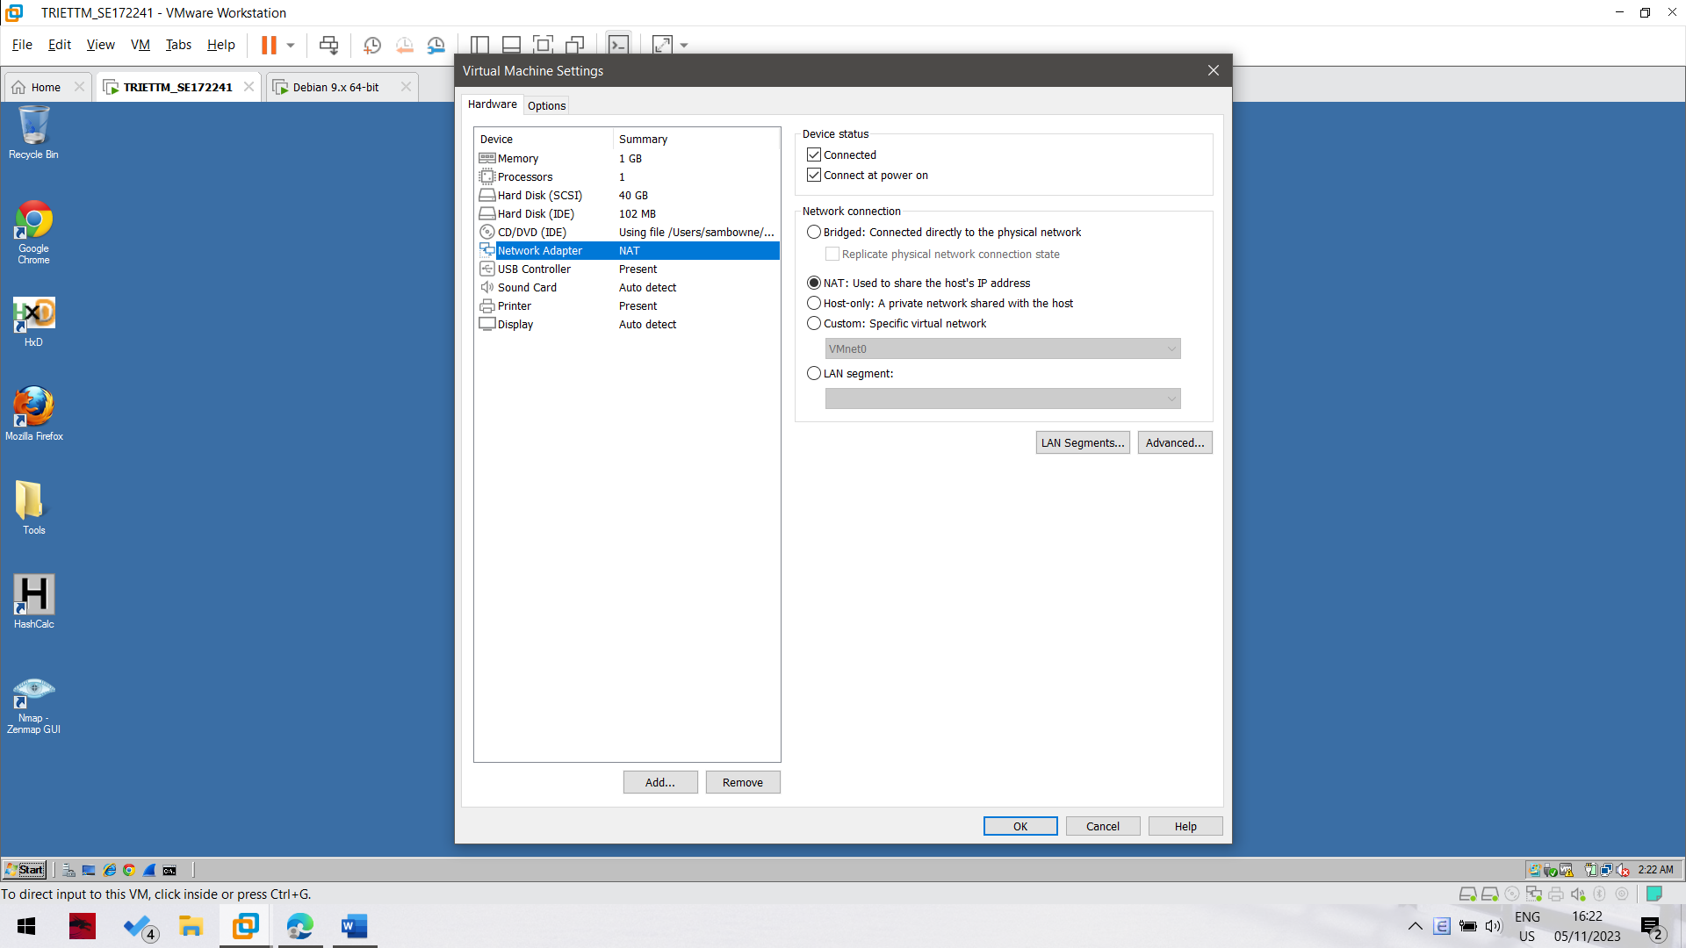**Setting the DNS Server**

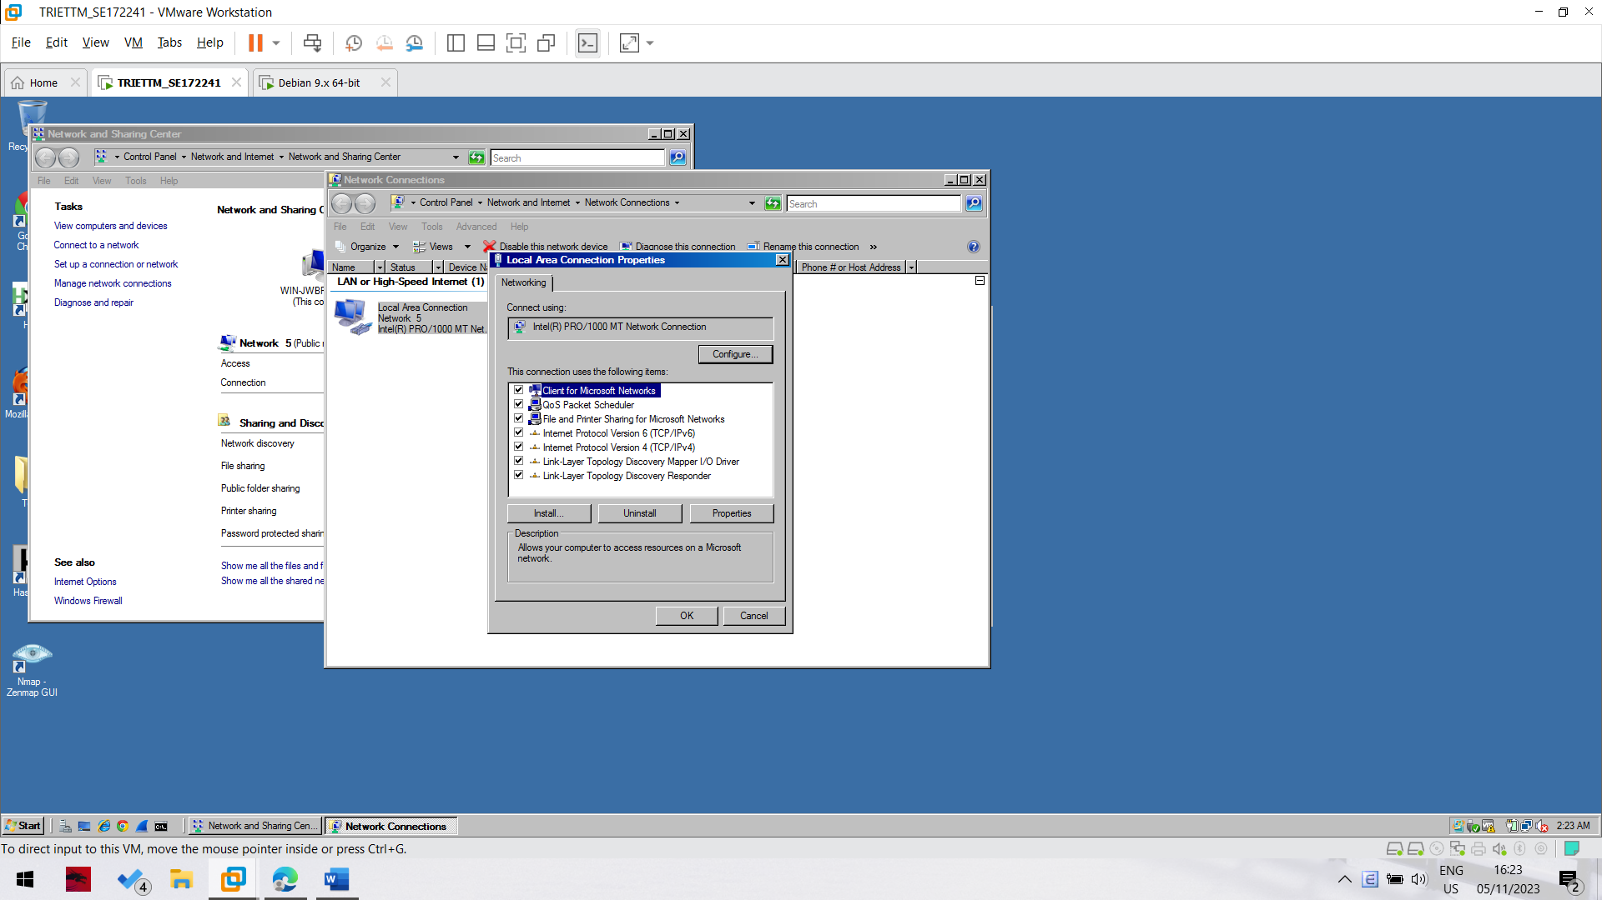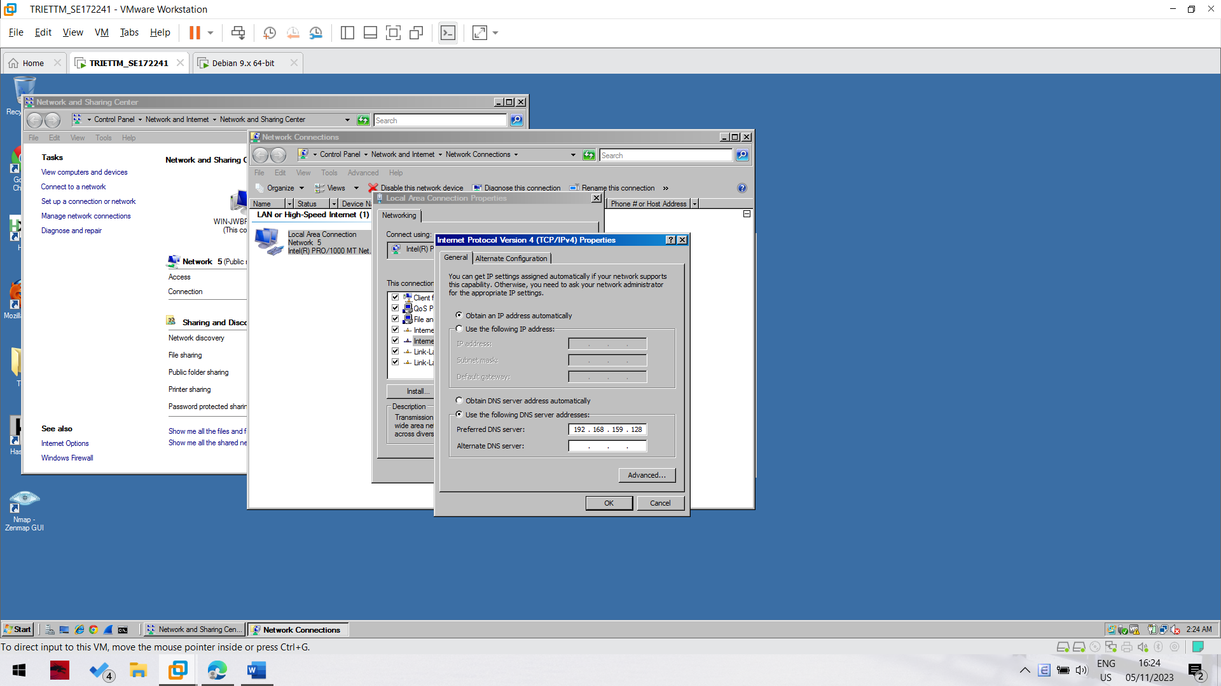

**Viewing an HTTP Web Page**

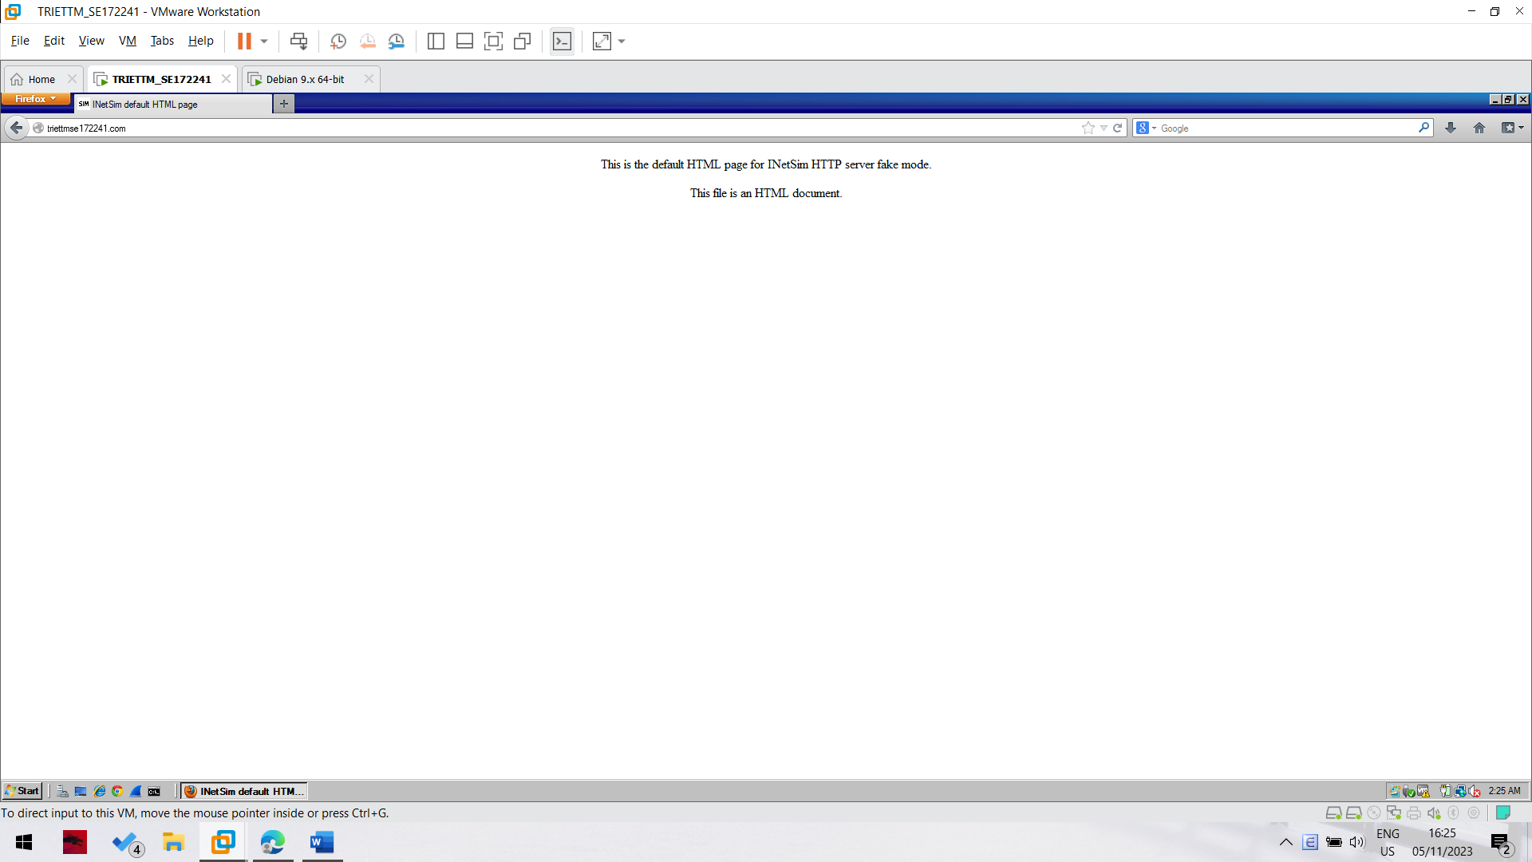

We successfully testing how inetsim behave

**Scanning YOURNAME.com**

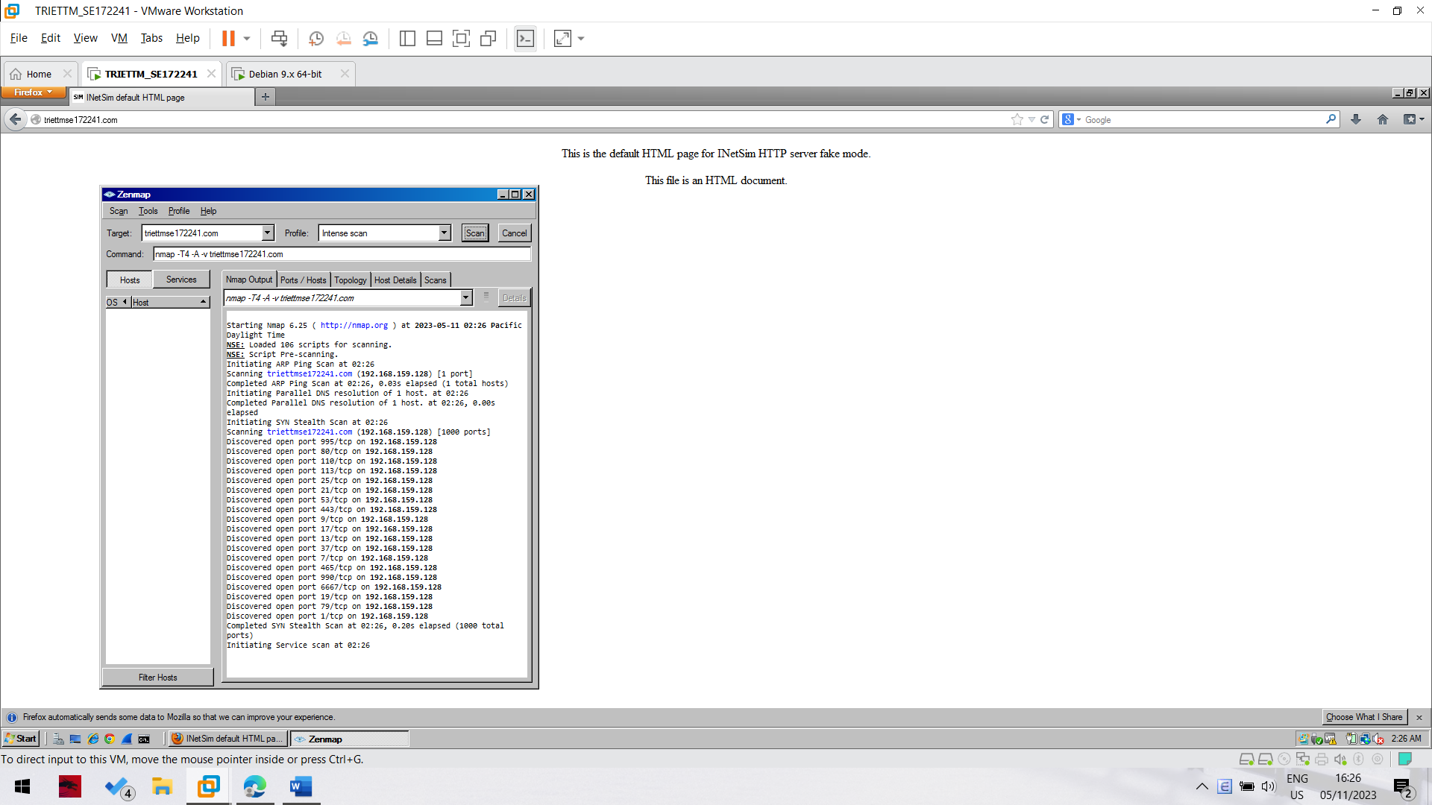

Nmap successfully scan the fake host that created by inetsim